
Stakeholder Salience Model
Template Example

Blank template on page 4.

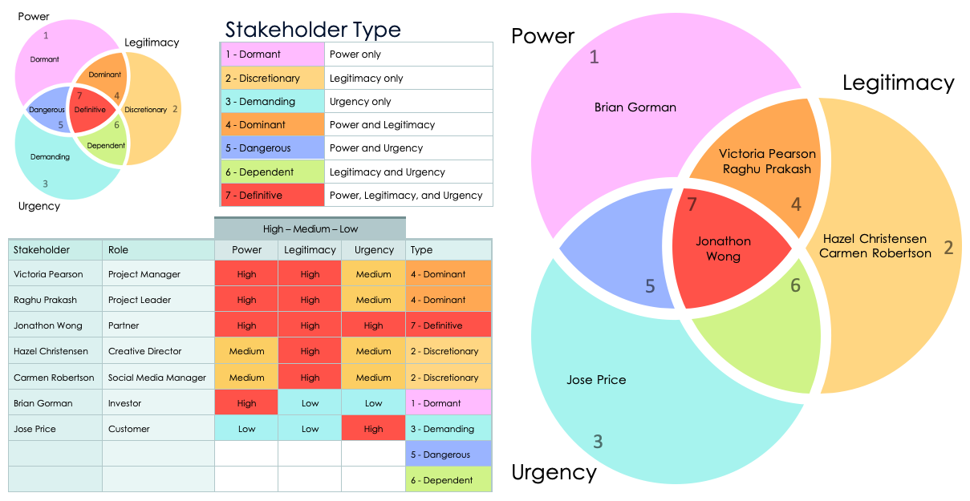

Stakeholder Salience Model Template Example

Project Name | Date
Cloud-Based PM Software Implementation | 01/01/20XX

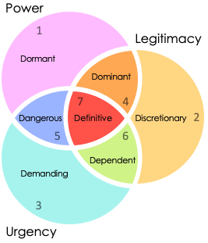 | Stakeholder Type
 | 1 - Dormant |  | Power only
 | 2 - Discretionary |  | Legitimacy only
 | 3 - Demanding |  | Urgency only
 | 4 - Dominant |  | Power and Legitimacy
 | 5 - Dangerous |  | Power and Urgency
 | 6 - Dependent |  | Legitimacy and Urgency
 | 7 - Definitive |  | Power, Legitimacy, and Urgency

 |  | High – Medium – Low
Stakeholder | Role | Power | Legitimacy | Urgency | Type
Victoria Pearson | Project Manager | High | High | Medium | 4 - Dominant
Raghu Prakash | Project Leader | High | High | Medium | 4 - Dominant
Jonathon Wong | Partner | High | High | High | 7 - Definitive
Hazel Christensen | Creative Director | Medium | High | Medium | 2 - Discretionary
Carmen Robertson | Social Media Manager | Medium | High | Medium | 2 - Discretionary
Brian Gorman | Investor | High | Low | Low | 1 - Dormant
Jose Price | Customer | Low | Low | High | 3 - Demanding
 |  |  |  |  | 5 - Dangerous
 |  |  |  |  | 6 - Dependent

Stakeholder Salience Model – Example

1
2
3
4
5
6
7
Jonathon Wong
Hazel Christensen
Carmen Robertson

Victoria Pearson
Raghu Prakash
Jose Price
Brian Gorman
Power
Legitimacy
Urgency

Stakeholder Salience Model Template

Project Name | Date

 | Stakeholder Type
 | 1 - Dormant |  | Power only
 | 2 - Discretionary |  | Legitimacy only
 | 3 - Demanding |  | Urgency only
 | 4 - Dominant |  | Power and Legitimacy
 | 5 - Dangerous |  | Power and Urgency
 | 6 - Dependent |  | Legitimacy and Urgency
 | 7 - Definitive |  | Power, Legitimacy, and Urgency

 |  | High – Medium – Low
Stakeholder | Role | Power | Legitimacy | Urgency | Type

Stakeholder Salience Model

Stakeholder
Stakeholder
Stakeholder
1
2
3
4
5
6
7
Stakeholder
Stakeholder
Stakeholder
Stakeholder
Stakeholder
Stakeholder
Stakeholder
Stakeholder
Stakeholder
Stakeholder
Stakeholder
Stakeholder
Stakeholder
Stakeholder
Stakeholder
Stakeholder
Stakeholder
Stakeholder
Power
Legitimacy
Urgency

DISCLAIMER

Any articles, templates, or information provided by Smartsheet on the website are for reference only. While we strive to keep the information up to date and correct, we make no representations or warranties of any kind, express or implied, about the completeness, accuracy, reliability, suitability, or availability with respect to the website or the information, articles, templates, or related graphics contained on the website. Any reliance you place on such information is therefore strictly at your own risk.

